**Procedure on how to fix this issue Your nodes are syncing…**

Date: Saturday 22nd April 2023

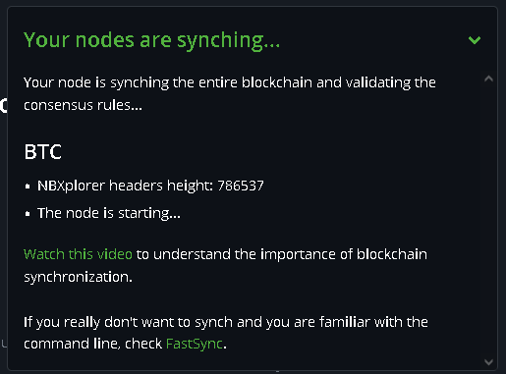

export NBXPLORER_BTCSTARTHEIGHT=786535

export NBXPLORER_BTCRESCAN=1

vi /root/BTCPayServer/btcpayserver-docker/Generated/docker-compose.generated.yml

change the value in that file to 786535

vi /root/BTCPayServer/.env

change the value in that file to 786535

systemctl restart btcpayserver

last time it lasted 8,585 blocks before causing the issue again

85,850 minutes to days

59 days

Things to fix:

You could also write a script to auto heal from this issue!

That would improve the uptime a lot